Improper Integrals, Gamma and Beta Functions
Improper Integrals
An improper integral is an extended concept of a definite integral that has infinite limits on one or both ends of the interval and/or an integrand that becomes infinite at one or more points within the interval of integration (Fig 1). Improper integral is called convergent if the limit of the integral exists with finite value and divergent if the limit of the integral does not exist or has infinite value.
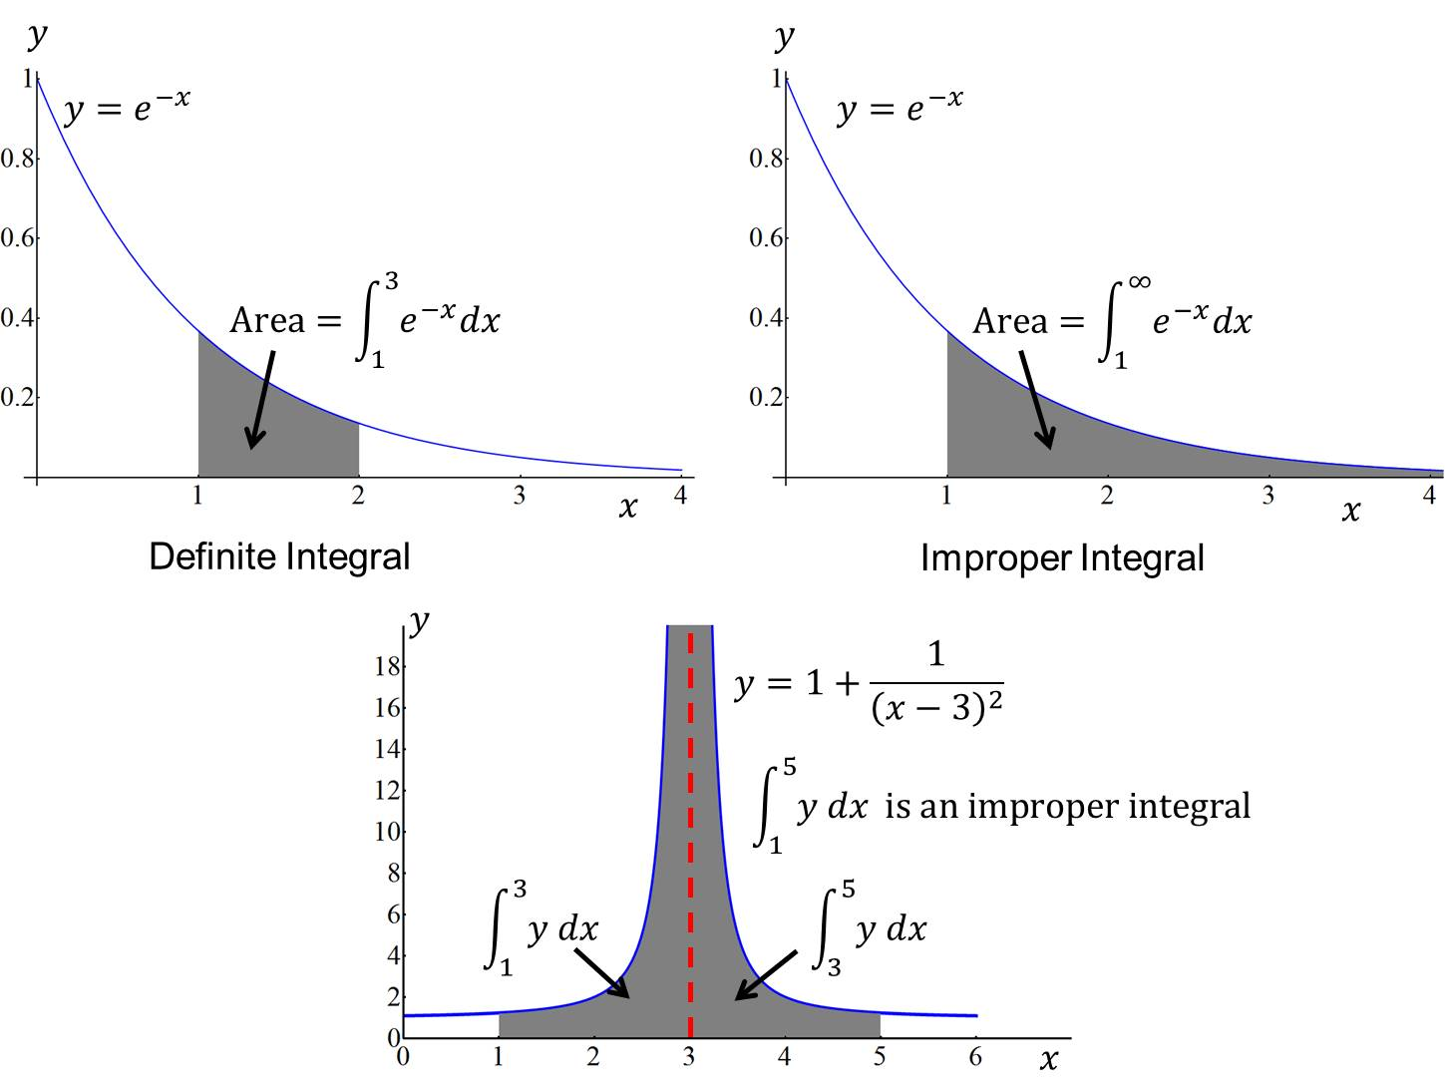
Figure 1: The above figures show the geometrical concept of the definite integral and improper integral.
Improper integral with infinite limit
(1)
(2)
(3)
Where c is any convenient point.

Example 1:
Example 2:
Hence the integral diverges.
Example 3:

Improper integral with infinite integrand
(1) Infinite at :
(2) Infinite at :
(3) Infinite at where :
Example 4:

Example 5:
Alternatively using substitution
$x=2\sin{θ}⇒dx=2\cos{ θ dθ}$
and $x=0⟹θ=0$and $x→2^{-}⟹θ={\frac{π}{2}}^{-}$ .
Thu $\int_{0}^{2}{\frac{dx}{\sqrt{4-x^{2}}}=\int_{0}^{π/2}{\frac{2\cos{ θ} dθ}{2\cos{ θ}}}}=\int_{0}^{π/2}{ dθ={\left[θ\right]}_{0}^{π/2}}=\frac{π}{2} .$

Exercise 1
1. Find, when they exist, the value of the following integrals:
(a) $\int_{1}^{∞}{\frac{1}{x^{2}}} dx$ (b) $\int_{-∞}^{0}{\frac{1}{\sqrt{3-x}}} dx$ (c) $\int_{-∞}^{∞}{xe^{-x^{2}}} dx$
(d) $\int_{0}^{3}{ \frac{1}{\sqrt{3-x}} dx}$ (e) $\int_{0}^{∞}{\frac{1}{1+x^{2}} dx}$ (f) $\int_{0}^{1}{\frac{1}{x^{2}} dx}$

Answers: (a)$1$ (b) Divergent (c)$0$ (d) $2√3$ (e) $\frac{π}{2}$ (f) Divergent

Gamma and Beta Functions
The Beta function was first studied by Euler and Legendre and was given its name by Jacques Binet. Just as the gamma function for integers describes fac-
torials, the beta function can define a binomial coefficient after adjusting indices. The beta function was the first known scattering amplitude in string theory, first conjectured by Gabriele Veneziano. It also occurs in the theory of the preferential attachment process, a type of stochastic urn process. The incomplete beta function is a generalization of the beta function that replaces the definite integral of the beta function with an indefinite integral. The situation is analogous to the incomplete gamma function being a generalization of the gamma function.

The Gamma function
The gamma function is defined by
,
where, for convergence of the integral, x> 0.
Integration by parts gives
, (x>0).
By using this recurrence relation when x = n, n being a positive integer ≥ 1, we have
But
and we get the important result
From definition
By substituting , we get
For evaluation of the integral advanced idea is needed and quoted the result without proof.
Example 1:
.
Example 2: Consider the integral$\int_{0}^{∞}{\frac{e^{-4x}}{x^{1/2 }}}dx$ .
Setting $=4x i.e. x=u/4$ , we have $dx=\frac{du}{4}$ and also note that for
$x=0 ⟹ u=0$and$x→∞⟹ u→∞$.
The integral becomes
$\int_{0}^{∞}{\frac{e^{-4x}}{x^{1/2}}}dx=\int_{0}^{∞}{\frac{2}{u^{1/2}}}e^{-u}\frac{du}{4}=\frac{1}{2}\int_{0}^{∞}{u^{-1/2}e^{-u} du}$
$=\frac{1}{2}Γ\left(\frac{1}{2}\right)=\frac{1}{2}\sqrt{π}$ .

Gamma Function for negative values
The recurrence relation for positive values of x is extended in defining gamma function for negative values of x. For$x<0$, the recurrence relation is written as
From the above definition it is clear that it becomes infinity at x = 0, and hence is not defined at all negative values of x. It is important to note that for negative values is not defined by the integral (1).
For example,
The Beta function
The beta-function is defined by the integral
which converges if
By putting, we have
That is
Thus beta-function is symmetric in m, n.
An alternative form of the beta-function, obtained from the definition by putting , is
(2)

Relation between the Gamma- and Beta-Functions

The relation between the Gamma- and Beta-Functions may be written as
The proof of the relation need advanced idea and not included here.
Gamma- and Beta-Functions may be used in evaluating integrals.
For example, from eq. (2), we get
Example 3: Evaluate the integral $\int_{0}^{2}{\frac{x^{2}}{\sqrt{2x-x^{2}}}} dx$ .
The integral can be written as,
$$I=\int_{0}^{2}{\frac{x^{2}}{\sqrt{2x-x^{2}}}} dx=\int_{0}^{2}{\frac{x^{2}}{\sqrt{2x\left(1-x/2\right)}}dx=\frac{1}{\sqrt{2}}\int_{0}^{2}{x^{3/2}}}{(1-\frac{x}{2})}^{-1/2}dx$$
Let $\frac{x}{2}=u$ or $x=2u$ and $dx=2du$.
Also note that
$x=0⟹u=0$and $x→2^{-}⟹ u→1^{-}$.
The integral becomes,
$$I=\frac{1}{\sqrt{2}}\int_{0}^{1}{{\left(2u\right)}^{\frac{3}{2}}{\left(1-u\right)}^{-\frac{1}{2}} 2 du }$$
$$=4\int_{0}^{1}{u^{\left(\frac{5}{2}-1\right)}{\left(1-u\right)}^{\frac{1}{2}-1}du }$$
$$=4Β\left(\frac{5}{2},\frac{1}{2}\right)=4\frac{Γ\left(\frac{5}{2}\right)Γ\left(\frac{1}{2}\right)}{Γ\left(3\right)}$$
$=4\frac{\left(\frac{3}{2}\right)\left(\frac{1}{2}\right)Γ\left(\frac{1}{2}\right)Γ\left(\frac{1}{2}\right)}{2}=3π/2$.

Example 4: Evaluate the integral $\int_{0}^{π/2}{\sin^{5/2}{x\cos^{3}{x dx}}}$ .
Using Beta function
$\int_{0}^{π/2}{\sin^{5/2}{x\cos^{3}{x dx=\frac{1}{2}Β\left(\frac{7}{4}, 2\right)=\frac{Γ\left(\frac{7}{4}\right)Γ\left(2\right)}{2Γ\left(\frac{15}{4}\right)}= \frac{Γ\left(\frac{7}{4}\right)×1)}{2(\frac{11}{4})(\frac{7}{4})Γ\left(\frac{7}{4}\right)}=\frac{8}{77}}}}$ .

Exercise 2
1. Prove that (a) , (b) ,
(c) , where$n$ is a positive integer .
2. (i) Show that $Β \left(m,n\right)=Β \left(n,m\right)$ , (ii) Using definition evaluate$Β (\frac{1}{2},2)$.
3. Using the relation , prove that .

4. Evaluate each of the following: (a) $Γ\left(-\frac{3}{2}\right),$ (b)$\frac{Γ\left(\frac{5}{2}\right)}{Γ(\frac{3}{2})}$ , (c) $\frac{6Γ\left(\frac{8}{3}\right) }{5Γ(\frac{2}{3})}$,
(d) $Β (\frac{3}{2}, 2)$.
5. Evaluate the following:
(a)$\int_{0}^{∞}{x^{4}{ e}^{-x}dx}$ (b)$\int_{0}^{∞}{{√xe}^{-x^{3}}dx}$ (c) $\int_{0}^{∞}{x^{3/2}e^{-x}dx}$
(d) $\int_{0}^{∞}{x^{6}e^{-2x}} dx$ (e) $\int_{0}^{∞}{√y}e^{-y^{2}} dy$ (f) $\int_{0}^{1}{x^{4}{\left(1-x\right)}^{3} dx }$
(g)$\int_{0}^{2}{\frac{x^{2}}{\sqrt{2-x}}} dx$ (h)$\int_{0}^{π/2}{\cos^{6}{θ dθ}}$ (i) $\int_{0}^{π/2}{\sin^{8}{θ dθ}}$
(j) $\int_{0}^{1}{y^{4}\sqrt{1-y^{2} }dy}$ (k) $\int_{0}^{π/2}{\sin^{7}θ{\cos^{5}θ{dθ}}}$
(l) $\int_{-π/2}^{π/2}{\sin^{6}φ\cos^{4}φ }dφ$.

Answers.
4. (a) $\frac{4}{3} \sqrt{π}$ (b) $\frac{3}{2}$ (c) $\frac{4}{3}$ (d) $\frac{4}{15}$ .
5. (a) 24 (b) $\frac{\sqrt{π}}{3}$ (c) $\frac{3}{4}√π$ (d) $\frac{45}{8}$ (e) $\frac{1}{2}Γ\left(\frac{3}{4}\right)$ (f) $\frac{1}{280}$ (g) $\frac{64√2}{15}$
(h) $\frac{5π}{32}$ (i) $\frac{35 π}{256}$ (j) $\frac{π}{32}$ (k) $\frac{1}{120}$ (l) $\frac{3π}{256}$.

